SCHEME OF EXAMINATION
AND
COURSE OF STUDY

CHOICE BASED CREDIT SYSTEM (CBCS)
And
LOCF

M. Sc. (CHEMISTRY)

(w.e.f. 2020-2021)

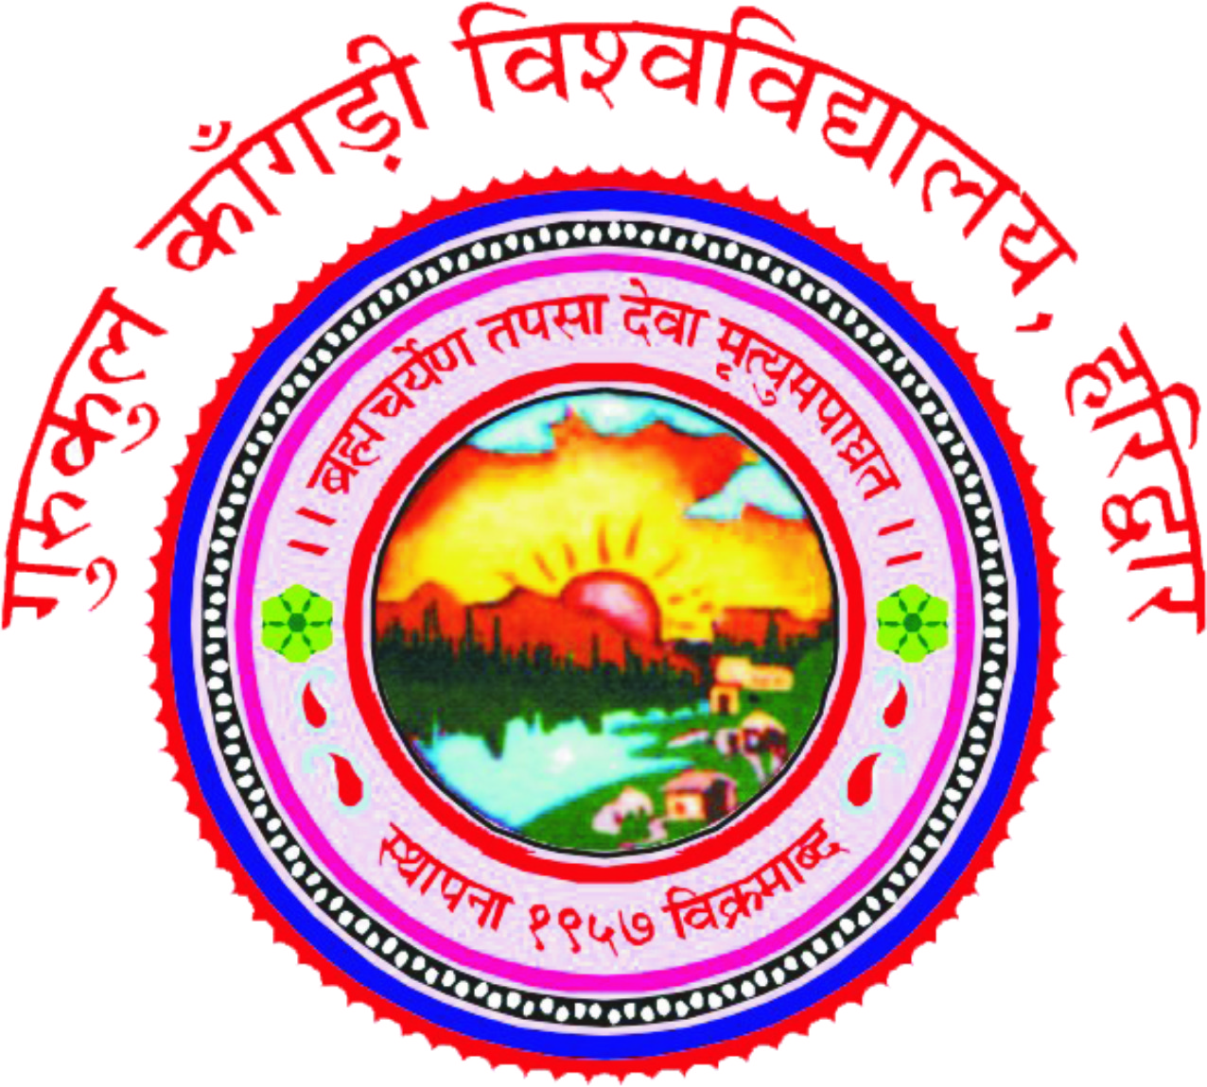

DEPARTMENT OF CHEMISTRY
GURUKUL KANGRI VISHWAVIDYALAYA, HARIDWAR

27 August, 2020
GURUKULA KANGRI VISHWAVIDYALAYA, HARIDWAR
M.Sc. CHEMISTRY SYLLABUS
S.N. | Subject  Code | Subject Title |  | Periods per week |  | Evaluation Scheme |  |  |  | Subject Total
 |  |  |  |  |  | Internal Assessment |  |  | ESE | Subject Total
S.N. | Subject  Code |  | L | T | P | Credit | CT | TA |  | Subject Total
 | M.Sc. I Year
 | Semester – I
1 | MCH-C101 | Core 1:General Inorganic Chemistry | 3 | 1 | - | 4 | 20 | 10 | 70 | 100
2 | MCH-C102 | Core 2:General Organic Chemistry | 3 | 1 | - | 4 | 20 | 10 | 70 | 100
3 | MCH-C103 | Core 3:General Physical Chemistry | 3 | 1 | - | 4 | 20 | 10 | 70 | 100
4 | MCH-E104 | Elective:Computer Application in Chemistry | 3 | 1 | - | 4 | 20 | 10 | 70 | 100
5 | MCH-C151 | Lab Course: 1 | - |  | 12 | 4 | 20 | 10 | 70 | 100
6 | MCH-C152 | Lab Course: 2 | - |  | 12 | 4 | 20 | 10 | 70 | 100
 |  |  |  |  |  | 24 | TOTAL |  |  | 600
 | Semester – II
1 | MCH-C201 | Core 1:Inorganic Chemistry and Related Techniques of Analysis | 3 | 1 | - | 4 | 20 | 10 | 70 | 100
2 | MCH-C202 | Core 2:Organic Chemistry and Related Techniques of Analysis | 3 | 1 | - | 4 | 20 | 10 | 70 | 100
3 | MCH-C203 | Core 3:Physical Chemistry and Related Techniques of Analysis | 3 | 1 | - | 4 | 20 | 10 | 70 | 100
4 | MCH-E204 | Elective:Chemistry in Vedic Literature and Ayurvedic Drugs | 3 | 1 | - | 4 | 20 | 10 | 70 | 100
5 | MCH-C251 | Lab Course: 1 | - |  | 12 | 4 | 20 | 10 | 70 | 100
6 | MCH-C252 | Lab Course: 2 | - |  | 12 | 4 | 20 | 10 | 70 | 100
 |  |  |  |  |  | 24 | TOTAL |  |  | 600
 | M. Sc. II Year
 | Semester – III
1 | MCH-C301 | Core 1:Analysis of Water and Waste Water | 3 | 1 | - | 4 | 20 | 10 | 70 | 100
2 | MCH-C302 | Core 2:Analysis of Soils | 3 | 1 | - | 4 | 20 | 10 | 70 | 100
3 | MCH-C303 | Core 3:Analysis of Oils, Fats, Soaps, Detergents, Essential oils, Paints and Varnishes | 3 | 1 | - | 4 | 20 | 10 | 70 | 100
4 | MCH-E304 | Elective:Analysis of Cement, Minerals, Alloys and Trace Metals | 3 | 1 | - | 4 | 20 | 10 | 70 | 100
5 | MCH-C351 | Lab Course: 1 | - |  | 12 | 4 | 20 | 10 | 70 | 100
6 | MCH-C352 | Lab Course: 2 | - |  | 12 | 4 | 20 | 10 | 70 | 100
 |  |  |  |  |  | 24 | TOTAL |  |  | 600
 | Semester – IV
1 | MCH-C471 | Industrial Training cum Project/Dissertation Work |  |  |  | 24 | 180* |  | 420 | 600
 |  |  |  |  |  | 24 | TOTAL |  |  | 600
 | TOTAL CREDITS |  |  |  |  | 96 | G. TOTAL |  |  | 2400
L = Lecture, P = Practical, CT =Cumulative Test, TA =Teacher Assessment, ESE= End semester Examination,
*Pre-submission Seminar

